Assignment 1[Based on class and object]
Q1. Define a class STOCK in C++ with following description:
Private Members:
• ICode of type integer (Item Code)
• Item of type string (Item Name)
• Price of type float (Price of each item)
• Qty of type integer (Quantity in stock)
• Discount of type float (Discount percentage on the item)
• A member function FindDisc () to calculate discount as per the following rule:
If Qty<=50 Discount is 0
If 50< Qty<=100 Discount is 5
If Qty>100 Discount is 10
Public Members:
• A function Buy ( ) to allow user to enter values for ICode, Item, Price, Qty and call function FindDisc ( ) to calculate the Discount.
• A function ShowAll () to allow user to view to content of all the data members.
Q2. Define a class Applicant in C++ with following description:
Private Members
• A data member ANo (Admission Number) of type long
• A data member Name of type string
• A data member Agg (Aggregate Marks) of type float
• A data member Grade of type char
• A member function GradeMe( ) to find the Grade as per the Aggregate Marks obtained by a student. Equivalent Aggregate Marks range and the respective Grades are shown as follows:
Aggregate Marks Grade
>=80 A
Less than 80 and >=65 B
Less than 65 and >=50 C
Less than 50 D
Public Members
• A function ENTER( ) to allow user to enter values for ANo, Name, Agg & call function GradeMe( ) to find the Grade.
• A function RESULT( ) to allow user to view the content of all the data members.
Q3. Define a class RESTRA in C++ with the following description:
Private Members
• FoodCode of type int
• Food of type string
• FType of type string
• Sticker of type string
• A member function GetSticker( ) to assign the following values for Sticker as per given FType :
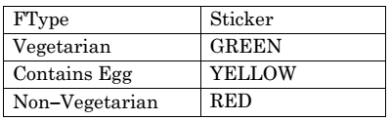
Public Members
• A function GetFood( ) to allow user to enter values for FoodCode, Food, FType and call function GetSticker( ) to assign Sticker.
• A function ShowFood( ) to allow user to view the content of all the data members.
Q4. Define a class Bus in C++ with the following specifications :
Data Members
• Busno – to store Bus No
• From – to store Place name of origin
• To – to store Place name of destination
• Type – to store Bus Type such as ‘O’ for ordinary
• Distance – to store the Distance in Kilometers
• Fare –to store the Bus Fare
Member Functions
• A function to initialize Type as ‘O’ and Freight as 500
• A function CalcFare( ) to calculate Fare as per the following criteria:
Type Fare
‘O’ 15*Distance
‘E’ 20*Distance
‘L’ 24*Distance
• A function Allocate( ) to allow user to enter values for Busno, From, To, Type
and Distance. Also, this function should call CalcFare( ) to calculate Fare.
• A function Show( ) to display the content of all the data members on screen.
Q5. Define a class Tourist in C++ with the following specification:
Data Members:
• CN0 - to store Cab No
• Ctype - to store a character 'A', 'B' or 'C' as City Type
• PerKM - to store per Kilo Meter charges
• Distance - to store Distance travelled (in Km)
Member Functions
• A constructor function to initialize CType as 'A' and CNo as '0000'
• A function CityCharges( ) to assign PerKM as per the following table:
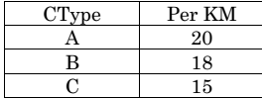
• A function RegisterCab( ) to allow administrator to enter the values for CNo and CType. Also, this function should call CityCharges( ) to assign PerKM Charges.
• A function Display( ) to allow user to enter the value of Distance and display CNo, CType, PerKM, PerKM*Distance (as Amount) on screen.
Q6. Write the definition of a class Photo in C++ with following description :
Private Members
– Pno // Data member for Photo Number (an integer)
– Category // Data member for Photo Category (a string)
– Exhibit // Data member for Exhibition Gallery (a string)
– FixExhibit // A member function to assign Exhibition Gallery as per
// Category as shown in the following table
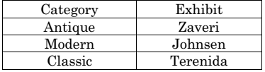
Public Members
– Register( ) //A function to allow user to enter values Pno, Category and call FixExhibit() function
– ViewAll( ) //A function to display all the data members

